**Advanced Git Topics like a Pro**

**Introduction:-**

Git, the distributed version control system, has become an indispensable tool for developers around the globe. While many are familiar with the basics of Git, there exists a realm of advanced techniques that can significantly enhance your workflow and help you overcome complex version control challenges. In this blog, we’ll delve into the world of advanced Git, exploring techniques and commands that will elevate your proficiency and efficiency.

**GIT Merge:**

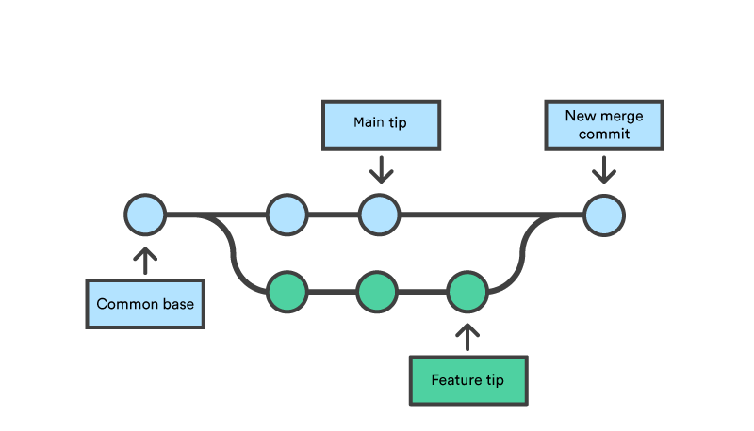

git merge <branchname> -m "Merge Message"

Let’s understand this with the help of an example:

* Suppose Our repo has multiple branches and we have to merge Branch2 to the Master Branch.
* Then switch to Branch2 and check the content of the File which you want to modify. Here we are modifying File1.

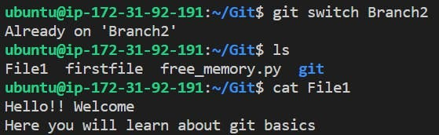

* Opening the File in Vi editor and adding a few lines of content.

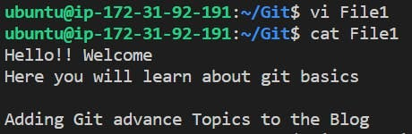

* Add it to the Staging area and commit it.

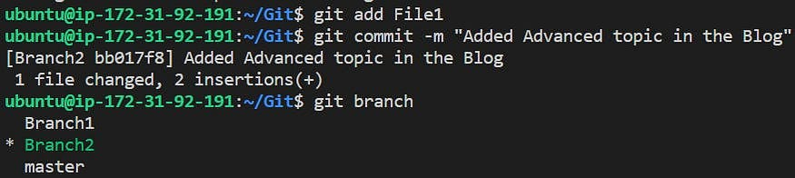

* Checking the logs of the Branch2

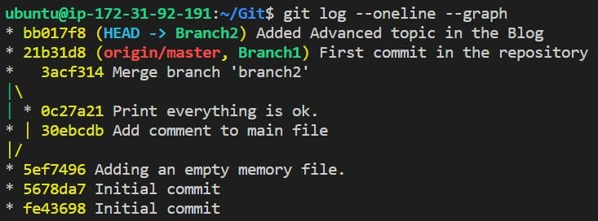

* Now switch to the Master Branch and edit the same file “File1” with different content this time.

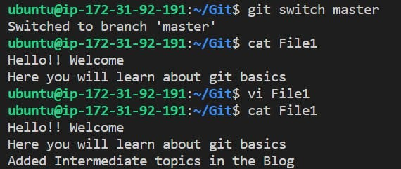

* Commit the File1 and check the logs

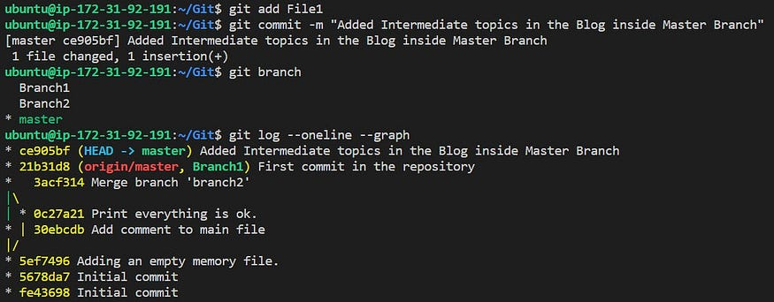

* Now applying git merge in Master Branch for Branch2 i.e.., Branch 2 will be merged with the Master Branch.

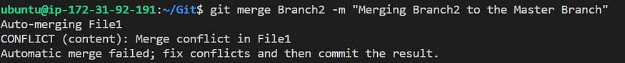

* Checking File 1 for merge conflict and keeping the required changes accordingly.

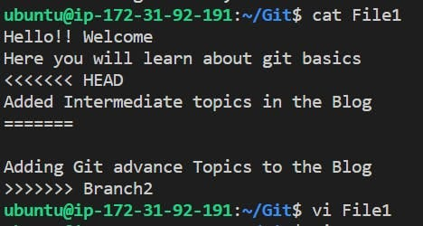

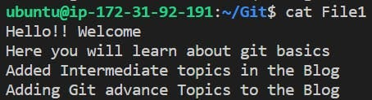

* Now File1 will be untracked so we will be committing it like below and check the logs:

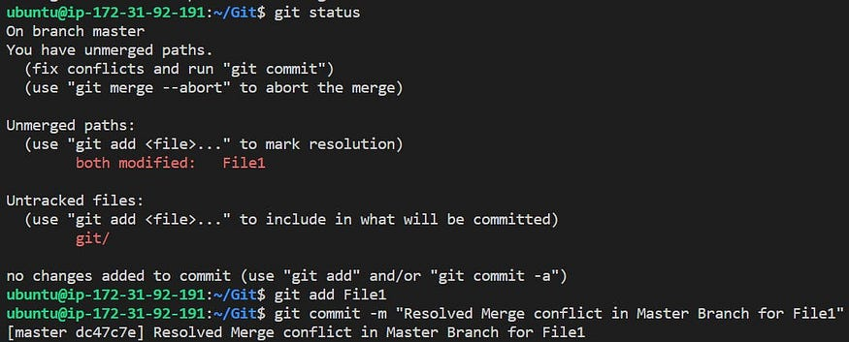

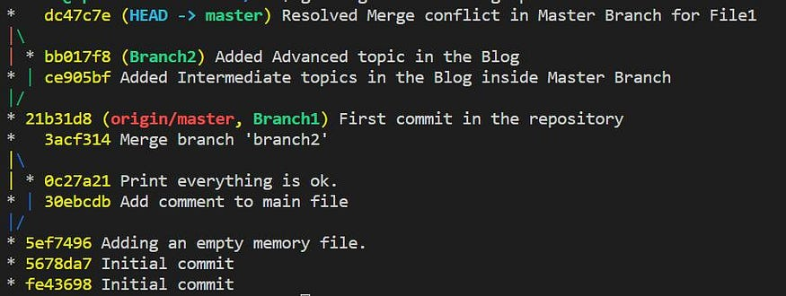

Merge completed 🥳

**GIT Commands to Solve Merge Conflict:-**

git diff

This helps to identify the difference between the state’s repositories/files.

git log --merge

This helps to produce the list of commits that are causing the conflict.

git checkout

This helps to undo the change made to the file or can be used to change the branch.

git reset --mixed

This command helps to undo changes to the Working Directory/Staging Area.

git merge --abort

This command helps in exiting the merge process and returning back to the state before the merging began.

**GIT Ignore**

* A [gitignore](https://git-scm.com/docs/gitignore" \t "_blank) file specifies intentionally untracked files that Git should ignore. Files already tracked by Git were not gets affected.
* There are mainly two kinds of .gitignorefiles: Local & Global
* It is placed inside root (/) directory of a Project. You can create a global .gitignore file, and the entries inside the file will b ignored by all of the Git Repositories.
* While creating a local gitignore file remembers to put a dot at the beginning and make it a normal text file. You can alter this file according to the requirements. Each line should list an additional file/folder or matching Patterns that you want Git to ignore.

**Patterns:**

* \* is used as a wildcard match
* / is used to ignore pathnames relative to the .gitignore file
* # is used to add comments to a .gitignore file

**Examples:**

# Ignore ALL .log files  
\*.log  
  
# Ignore all text files  
\*.txt  
  
# Ignore ALL files in ANY directory named temp  
temp/  
  
# Ignore Mac system files  
.DS\_store  
  
# Ignore node\_modules folder  
node\_modules  
  
# Ignore files related to API keys  
.env  
  
# Ignore SASS config files  
.sass-cache

To add or change your global .gitignore file:

git config --global core.excludesfile ~/.gitignore\_global

This will create the file ~/.gitignore\_global. You can edit this file the same way as a local .gitignore file. All of your Git repositories will ignore the files and folders listed in the global .gitignore file.

**Untrack Already Committed Files via New Gitignore:**

To untrack a single file, ie stop tracking the file but not delete it from the system use:

git rm --cached filename

To untrack all the files in .gitignore, First commit the code changes

git rm -r --cached

This will remove any changed file from the Index/Staging Area then add and commit it:

git add .  
git commit -m ".gitignore is now working!!!!"

Notes: To undo git rm --cached filename, use git add filename

For More Information refer:

* Git documentation: [gitignore](https://git-scm.com/docs/gitignore" \t "_blank)
* Ignoring files: [GitHub](https://help.github.com/articles/ignoring-files/)
* Useful .gitignore templates: [GitHub](https://github.com/github/gitignore)

**GIT Restore**

Git Restore is used to unstage or discard uncommitted local changes in a file.

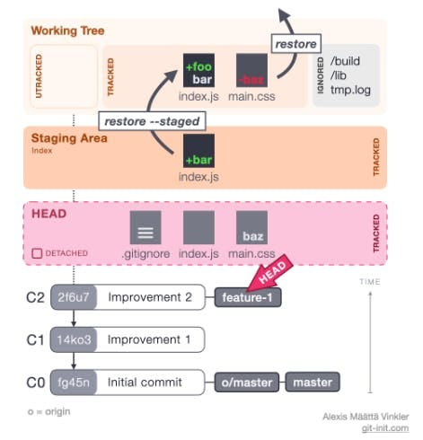

git restore [--source=commit-hash] [--worktree] [--staged] [--] file

* — worktree means to make the restore to worktree
* — staged means make the restore to — staged.
* specify both — staged and — worktree to make the restore from — source to both the worktree and the staging-area
* when — source is specified the restore is always from the source
* when — source is not specified and — staged is given the restore is from the HEAD
* when neither — source nor — staged are specified then the restore is from staging area to the work tree

Suggestion — Use git restore to bring the files from

* commit blob to the staging area and/or work tree.
* staging-area to worktree

Notes: If you have deleted the file and already committed the changes, you need to use the git checkout command to restore the file.

**Example:**

* I have created an email script file like below:

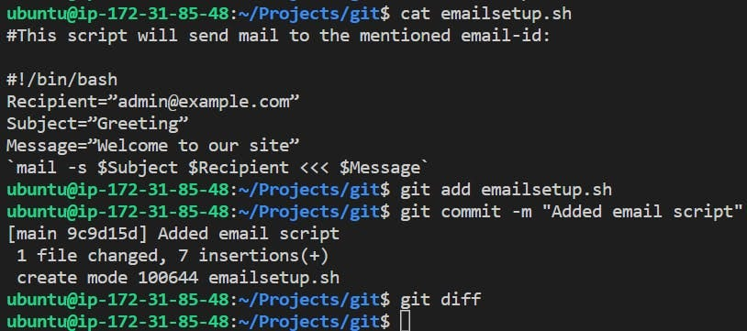

* Now I want to change the mail id to User1@example.com and check the difference from the last commit to the current state:

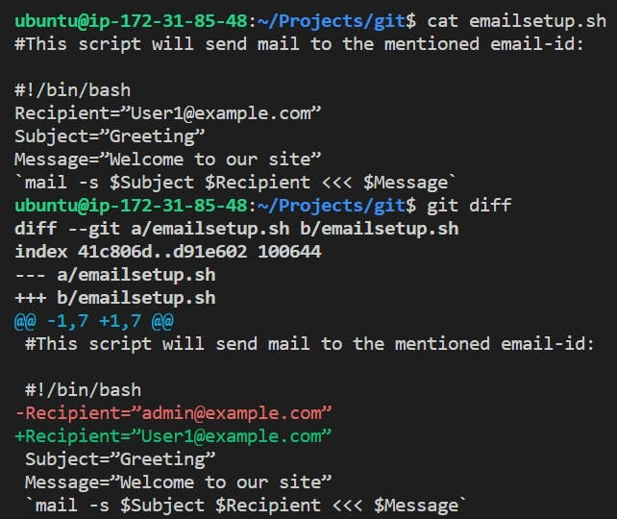

* It shows that the Red highlighted part is removed and the Green highlighted part is added recently.
* But then the requirement was altered and it was confirmed that the mail should be sent to admin instead of User1. And luckily we have not committed the changes yet so, in this scenario we will use git restore to get the script file in the previous state as it was in the last commit.

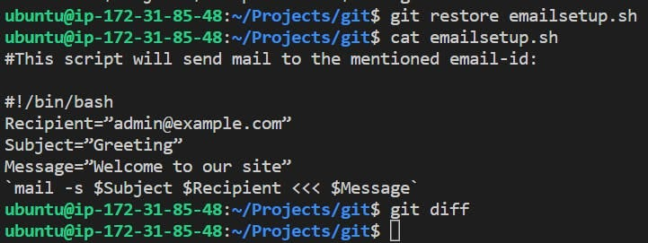

For More Information refer:

* Git documentation: [git restore](https://git-scm.com/docs/git-restore)
* Git restore more [info](https://blog.git-init.com/how-to-undo-changes-in-git-using-reset-revert-and-restore/)

**GIT Revert**

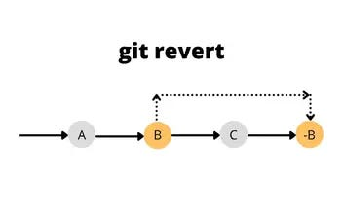

git revert <hashid>

* It is a forward-moving undo operation that offers a safe method of undoing changes. We require the commit Id to revert the changes
* *Git Revert* is used when we want to take a previous commit and add it as a new commit, keeping the log intact.
* Instead of deleting or orphaning commits in the commit history, a revert will create a new commit that inverses the changes specified. Git revert is a safer alternative to git reset in regards to losing work.
* Revert will also generate a hash id, as everything is a commit in git

**Example:**

* Suppose you created a script to send an email and initially the requirement was to add email-id as [admin@example.com](mailto:admin@example.com). You worked on it and committed it like below:

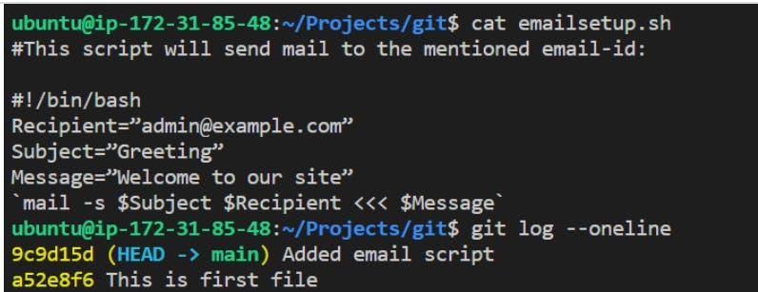

* After some time, they mentioned adding [User1@example.com](mailto:User1@example.com) instead of Admin. You made the changes and committed it:

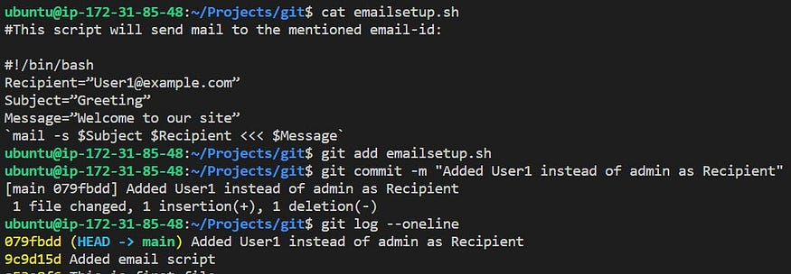

* After further discussion, the requirement gets concluded that email needs to be sent to admin if the issue arrives not the user1. Here we will be using git revert to revert to the desired commit:

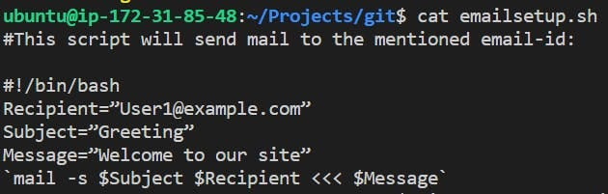

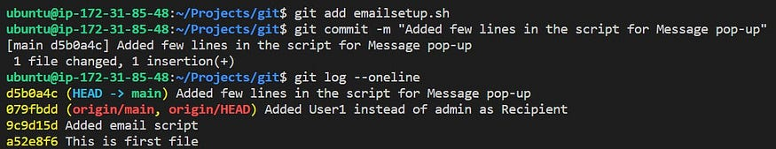

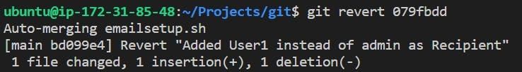

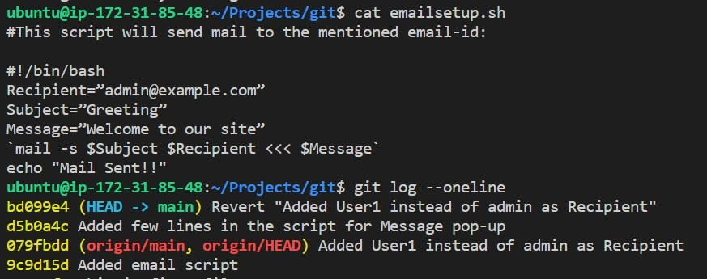

* If you observe it closely then the git revert also creates a separate commit.

**GIT Reset:-**

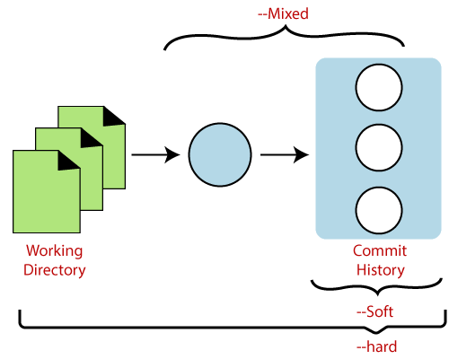

git reset <index/commit number you want to roll back to>

This command is a little more complicated. It does a couple of different things depending on how it is invoked. It modifies the index (the so-called “staging area”) Or it changes which commit a branch head is currently pointing at. This command may alter existing history (by changing the commit that a branch references).

* You were in a detached head state — git reset would move the HEAD to the specified commit hash. Just like git checkout commit-hash
* You were not in a detached head state — git reset would move the entire (HEAD -> branch) to the specified commit hash. If this resulted in commits that no branch is ahead of then those commits are removed from Git history

git reset also has three options — soft, — mixed, — hard. How should your work tree and Index(staging area) look once you have moved your HEAD to a different commit?

* **hard**— Both the Worktree and the Index match the files in the new commit you moved to. Here file will not come in the staging area after a hard reset (not advisable🙅🏾‍♀️).
* **mixed**(**default**) — Worktree remains as it was before you ran git reset and Index matches the files in the new commit you moved to.
* **soft**— Worktree and Index both remain as they were before you ran git reset.Here file will come to the staging area after a soft reset. So, you need to unstage it so it will not be tracked:

git status #To check the files which are in working area  
 git restore --staged <Filename>

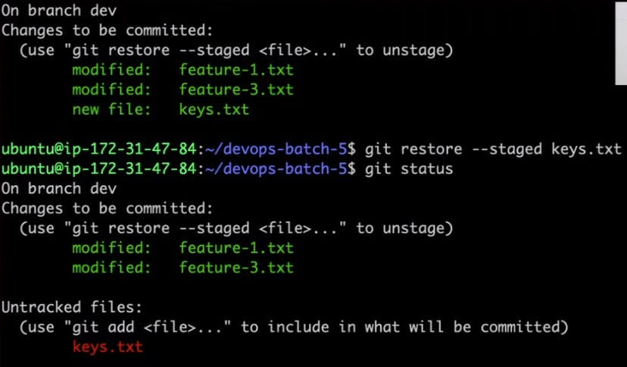

git reset for the most part can be replicated using a combination of git checkout, git branch -D and git restore except that there is no easy way to control the contents of work tree and staging area as well except if you don’t use git reset

Suggestion: Have you made a few commits that should not have been made and have not pushed the changes to the public repo? Is it best to just have it as if these commits never existed? Use git reset. If you have pushed the changes to the public repo then as discussed earlier you want to use git revert.

Ex: Git RESET soft is used to roll back changes to previous commits i.e.., The index will be changed and show the previous one but the content will not be rolled back.

**Example:**

* Here we have reverted the changes that created logs as well:

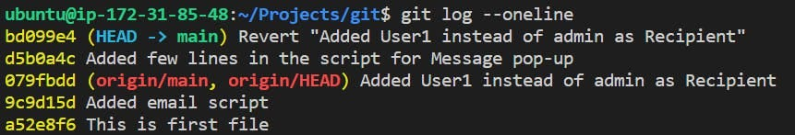

* In order to go back to previous commit and wipeout the undesired commit logs, we will use soft reset

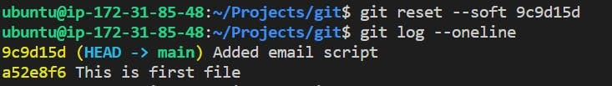

* If you want to change the content of the file use git reset --hard:

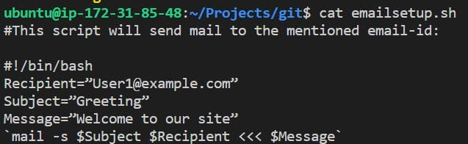

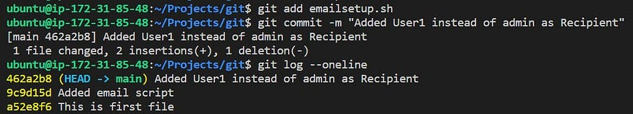

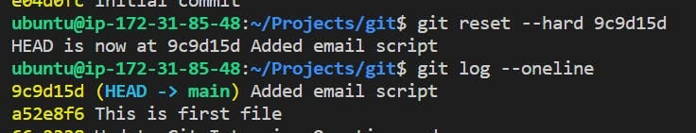

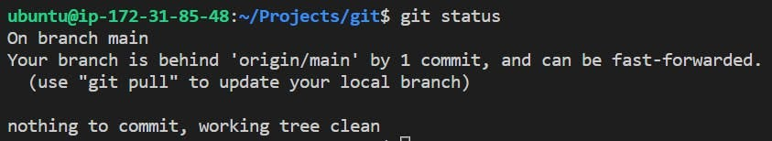

**GIT Cherry Picking:-**

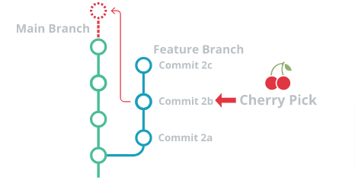

* Cherry Picking is the act of picking a commit from a branch and applying it to another.
* git cherry-pick can be used for undoing changes. For example, when a commit is accidentally made to the wrong branch. You can switch to the correct branch and cherry-pick the commit to where it should belong.
* It is a powerful command that enables arbitrary Git commits to be picked by reference and appended to the current working HEAD.

git cherry-pick <commitSha/commitID>

**Git cherry-pick can also be passed some execution options.**

* Passing the -edit option will cause git to prompt for a commit message before applying the cherry-pick operation

-edit

* The --no-commit option will execute the cherry pick but instead of making a new commit it will move the contents of the target commit into the working directory of the current branch.

--no-commit

* The --signoff option will add a 'signoff' signature line to the end of the cherry-pick commit message

--signoff

**Choose Wisely when to use GIT Cherry-Pick**

* Git Cherry-Pick is a useful tool but not always a best practice.
* Cherry Picking can cause duplicate commits.
* Still today traditional merges are preferred instead of cherry picking.
* Sometimes a feature branch may go stale and not get merged into main.
* Sometimes a pull request might get closed without merging. Git never loses those commits and through commands like git log and git reflog they can be found and cherry picked back to life.

**GIT Squash:-**

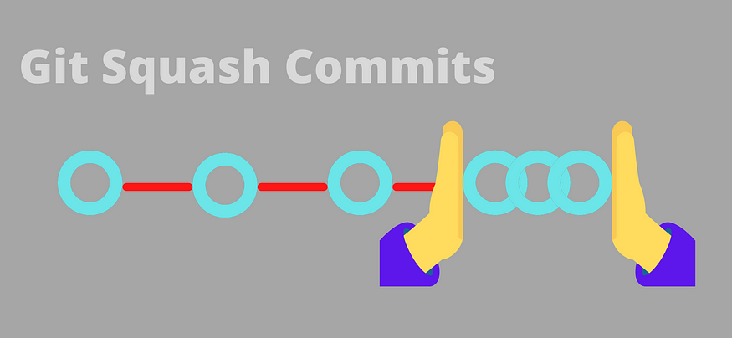

* “squash” in Git means to combine multiple commits into one. You can do this at any point in time (by using Git’s “Interactive Rebase” feature), though it is most often done when merging branches.
* Git Squash is a pretty powerful tool inside Git. It allows you to basically pick up a bunch of commits and just squash them together into a big commit.

git mege --squash  
git rebase -i HEAD~n

**Choose Wisely When to Squash:**

* If you decide to squash before merging, then all of those individual commits from your feature branch will be combined into a single commit. The main commit history, therefore, will only show a single commit for this integration.
* If you decide *AGAINST* squashing, all of your individual commits will be preserved as such.

**How to Squash Commits in Git via Interactive Rebase:**

git rebase -i HEAD~n

In this process, you will grab all the commits with the git rebase command with the i flag and put them together with squash. Apart from squashing, the command also allows you to drop commits, reword commit messages, and add new files.

I have these commits I would like to combine into one:

In this process, you will grab all the commits with the git rebase command with the i flag and put them together with squash. Apart from squashing, the command also allows you to drop commits, reword commit messages, and add new files.

I have these commits I would like to combine into one:

**Example:**

* Created Feature2.txt file and added few commits like below:

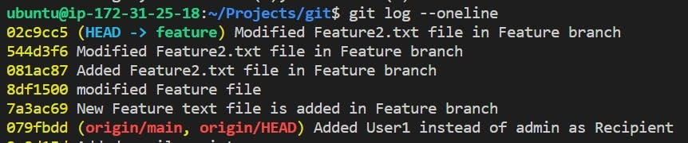

* I will squash the latest two commits via interactive rebase, so will use:

git rebase -i HEAD~n  
  
#where n could be the number of lines  
example: git rebase -i HEAD~4

* It will open up nano editor and we have to modify the lines which we want to squash into one.

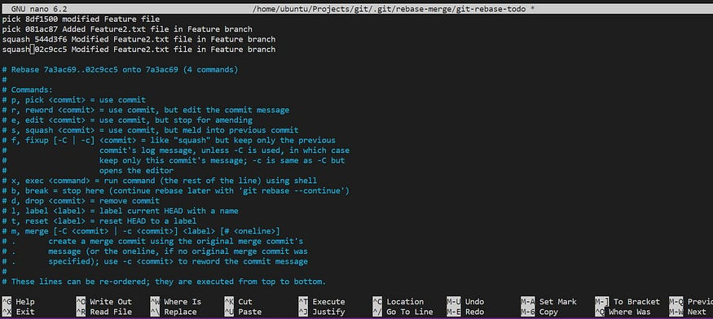

Press Ctrl+X and give CTRL+Y. comment others Commits and write the one with which you want this merge to reflect into Feature branch’s latest commit:

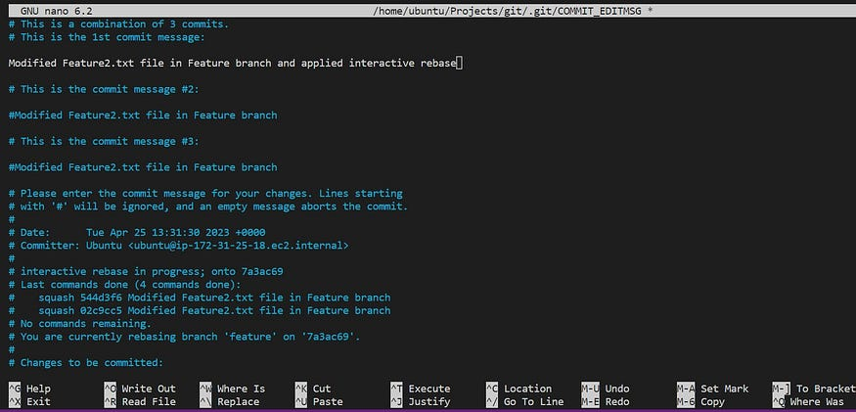

* Checking git log on feature Branch:

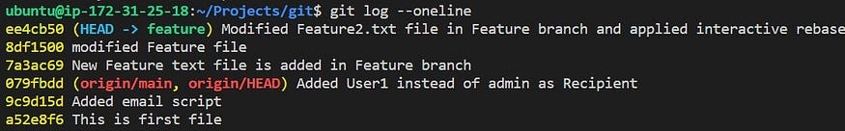

**GIT STASH:-**

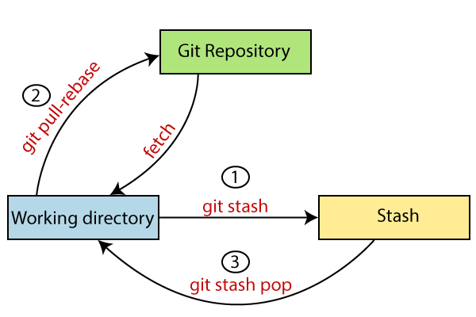

* It temporarily saves/stashes changes you’ve made to your working copy so you can work on something else, and then come back and re-apply them later on. Stashing is handy if you need to quickly switch context and work on something else, but you’re mid-way through a code change and aren’t quite ready to commit.
* The git stash command takes your uncommitted changes (both staged and unstaged), saves them away for later use, and then reverts them from your working copy.
* At this point you’re free to make changes, create new commits, switch branches, and perform any other Git operations; then come back and re-apply your stash when you’re ready.
* Note that the stash is local to your Git repository; stashes are not transferred to the server when you push.

**Git Stash Save (Saving Stashes with the message):**

In Git, the changes can be stashed with a message. To stash a change with a message, run the below command:

git stash save "<Stashing Message>"



**Git Stash List (Check the Stored Stashes)**

It will show the list of stashes. It will show all the stashes with indexing as stash@{0}: stash@{1}. This is helpful if you have multiple files in Stash and you want to un-stash it to the desired one.

git stash list



**Git Stash Changes**

We can track the stashes and their changes. To see the changes in the file before stash and after stash operation, run the below command:

git stash show

The above command will show the file that is stashed and changes made on them. Consider the below output:

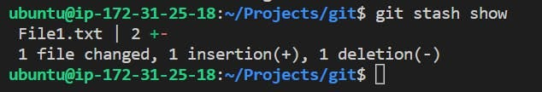

We can exactly track what changes are made on the file. To display the changed content of the file, perform the below command

git stash show -p  
# p is for partial stash

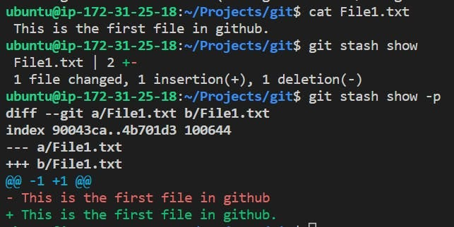

**How to Reapply Your Stashed Changes?**

* You can reapply previously stashed changes with git stash pop:
* *Popping* your stash removes the changes from your stash and reapplies them to your working copy.
* Alternatively, you can reapply the changes to your working copy *and* keep them in your stash with git stash apply
* This is useful if you want to apply the same stashed changes to multiple branches.
* Now that you know the basics of stashing, there is one caveat with git stash you need to be aware of: by default Git *won't* stash changes made to untracked or ignored files.
* The key difference between git stash pop and apply involves the stash history. When a developer uses the git stash apply command, the most recently saved stash overwrites files in the [current working tree](https://www.theserverside.com/video/Understand-the-Git-working-tree-status-command-for-easy-DVCS) but leaves the stash history alone. In contrast, the pop command restores files but then deletes the applied stash. If a developer ever feels the need to use that restored stash again, it will be saved in the local file system.
* Think of the git stash pop command as a two-step process. It pulls the most recent stash from history, makes the appropriate changes to files in the local workspace and then deletes that entry from the stash history. Once the git stash pop command is successfully invoked, the stash is permanently deleted and can never be accessed again.

**Git Stash Apply**

You can re-apply the changes that you just stashed by using the git stash command. To apply the commit, use the git stash command, followed by the apply option. It is used as:

git stash apply

The above output restores the last stash. Now, if you will check the status of the repository, it will show the changes that are made to the file.

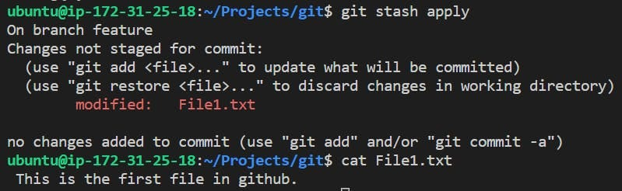

you can see that the repository is restored to its previous state before stash. It is showing output as “Changes not staged for commit.” So you have to add thema nd commit to apply the changes:

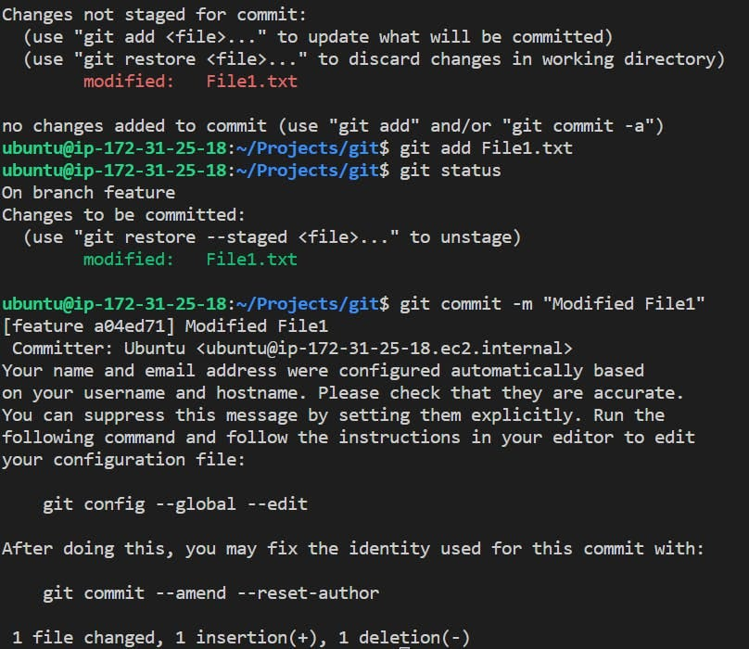

But still that Stash is reflecting while listing the stashes:



To delete it from stash list either use git stash drop (This will delete the stash forever)or git stash pop (This will unstash the file and remove the entry in stash list)

In case of more than one stash, you can use “git stash apply” command followed by stash index id to apply the particular commit. It is used as

git stash apply <Stash Index ID>

If we don’t specify a stash, Git takes the most recent stash and tries to apply it.

**Git Stash Pop (Reapplying Stashed Changes)**

Git allows the user to re-apply the previous commits by using the git stash pop command. The popping option removes the changes from stash and applies them to your working file.

The git stash pop command is quite similar to git stash apply. The main difference between both of these commands is stash pop command that deletes the stash from the stack after it is applied.

git stash pop   
git stash pop <Stash Index>

It will re-apply the previous commits to the repository. Consider the below output.

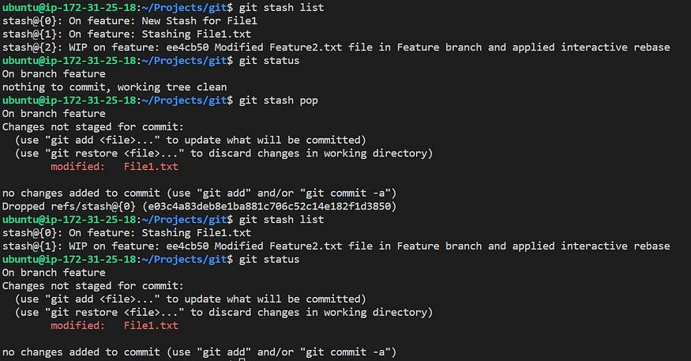

**Git Stash Drop (Unstash)**

The git stash drop command is used to delete a stash from the queue. Generally, it deletes the most recent stash. Caution should be taken before using the stash drop command, as it is difficult to undo if once applied.

The only way to revert it is if you do not close the terminal after deleting the stash. The stash drop command will be used as:

git stash drop

for deleting a particular Stash from the list then use:

git stash drop <stash id>

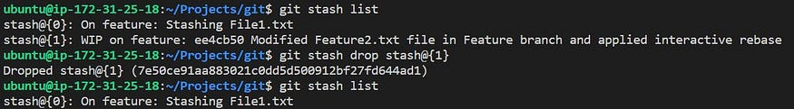

**Git Stash Clear**

The git stash clear command allows deleting all the available stashes at once. To delete all the available stashes that exist in the repository.

git stash clear

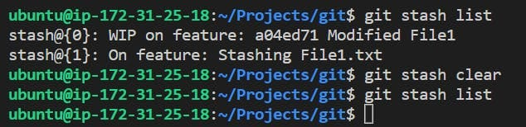

**Git Stash Branch**

If you stashed some work on a particular branch and continue working on that branch. Then, it may create a conflict during merging. So, it is good to stash work on a separate branch.

The git stash branch command allows the user to stash work on a separate branch to avoid conflicts. The syntax for this branch is as follows:

git stash branch <Branch Name>

The above command will create a new branch and transfer the stashed work on that.

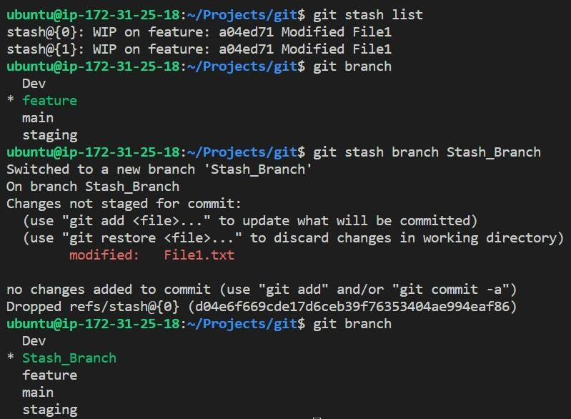

**Conclusion:-**

Mastering advanced Git techniques is essential for developers who want to streamline their workflow, collaborate seamlessly, and navigate the complexities of version control effectively. By incorporating these advanced Git concepts into your repertoire, you’ll gain a deeper understanding of the tool and unlock its full potential for your projects. Whether you’re working on a solo project or collaborating with a team, advanced Git skills will undoubtedly elevate your development experience.

Follow me on Linked-in and Github for further updates- <https://www.linkedin.com/in/sushantkapare/>

<https://github.com/SushantOps>